The Emotional Animals Game is played by rolling the "dice" and acting out whatever you roll.
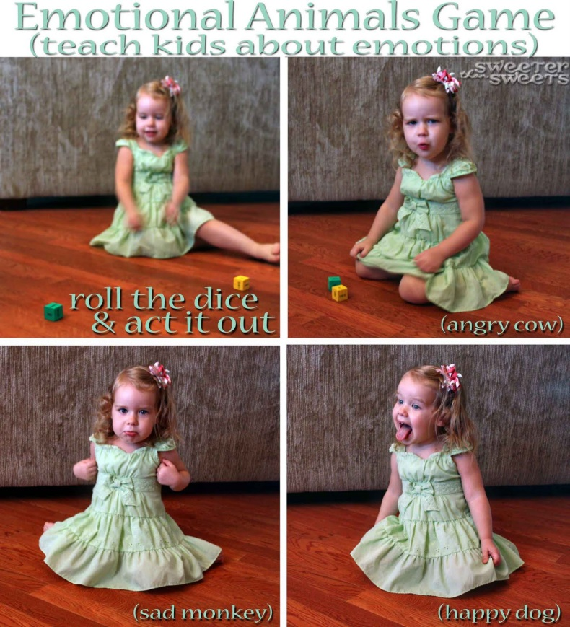
Easy as that!
All you really need for this game is a permanent marker and two square solid-coloured blocks from a set like this:
Now you're going to want to pick out some emotions to write on one of your dice. There are four basic emotions, from which most other emotions come: mad, sad, happy and scared. Then there are plenty of other options for you to pick from. Just think about which feelings or states you'd want to teach your child(ren) about.
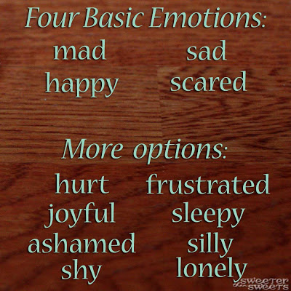

Next, pick six animals that are relatively easy to mimic. We chose: cat, dog, monkey, cow, mouse and elephant. (Elephant is a little harder than the others...maybe a bird would've been easier?)
This game can also be taken a step further, depending on your child's readiness to explore emotions deeper. For instance, when Little Sweets acts out a mad animal, we can talk about the best ways to handle anger. Put it in terms of how an animal might react because, again, young children tend to relate well to animals.
Personal space games
The basic concept of "personal space" is an important social rule. The idea is that each of us has a certain amount of space around us that makes us feel safe. When someone crosses into our personal space, we feel uncomfortable. It's an important concept for children to learn so that they do not invade someone else's personal space. Personal space can be taught through various activities and games.
How Close Can You Go?
In this activity, divide the class in half and make two separate parallel lines. Each person will then be asked to pair off with a person across the room in the other line. They must then begin a conversation with the person across from them with the following question: "If you had a wish, what would you wish to come true?" After that, the lines of students move toward each other while continuing to discuss the question. When one student felt uncomfortable, he or she should say, "Stop." After this, the class can compare their different comfort levels of personal space.
Personal Space Circle
In this activity, use a long rope to create a circle on the floor. Overlap the ends so that the circle can be made bigger later. Sit one student in the circle and explain that personal space is smaller for people that we feel very close to, such as parents and siblings. Then, make the circle a bit larger and explain that the circle gets a little bigger for friends and teachers, because we know them but aren't as close to them as family. Last, make the circle as large as it can be and explain that for strangers, the personal space circle is much bigger.
Personal Space Group Exercise
Students stand up in a room and partner with someone. Students will then stand facing their partners and have 4 to 6 feet of space behind them. Next, they will be asked to notice the natural distance between them and their partner, as well as other pairs in the room. Ask the students to take two steps forward, and they will now be within 1 foot of their partner. Ask them how it feels to be this close. Most of them likely will say it was uncomfortable and you can reinforce the value of personal space.
Personal Space Tag - In this activity, students start in their personal space holding three fingers. The teacher will select one or two taggers in the class. When the teacher says "go," the chosen taggers will try to tag other members of the class. When a student is tagged, a student falls down or students bump into each other, that student loses a point and takes one of their fingers down. When a student loses all three points, they are out. Each finger represents a violation of personal space.

